## Lab 2: Universal Gates

### **Objectives**

* Understand the concept of Universal Gates (NAND & NOR)
* Implement the basic logic gates using universal gates
* Implement boolean functions using universal gates
* Understand gate level minimization

### **Apparatus**

* Trainer Board
* IC 7400 Quadruple 2-input NAND gates
* IC 7402 Quadruple 2-input NOR gates

### **Theory**

A universal gate is a gate which can implement any Boolean function without need to use any other gate type. The NAND and NOR gates are universal gates. In practice, this is advantageous since NAND and NOR gates are economical and easier to fabricate and are the basic gates used in all IC digital logic families.

**Figure C1** shows the implementation of NOT, AND & OR gates using only NAND gates.

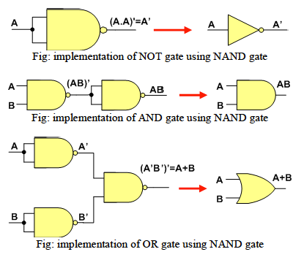

Figure C1: NAND as a universal gate

* 1. Procedure

1. Verify each of the NAND gate equivalent circuits in **Figure C1** to perform the same operations of the basic gates.
2. Design, construct and test the implementations of XOR and XNOR gates using NAND gates only. Show the circuits in **Figure F1** (Section F), clearly labeling the pin numbers.
3. Design, construct and test the implementations of NOT, AND, OR, XOR and XNOR gates using NOR gates only. Show the circuits in **Figure F2** (Section F), clearly labeling the pin numbers.

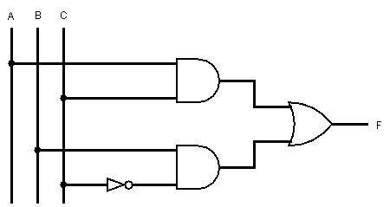

Figure D1: A combinational circuit

1. Complete the truth table for the circuit in **Figure D1** in Table F1 (Section F).
2. Convert the circuit in **Figure D1** to a NAND gate equivalent circuit, showing the steps involved and clearly labeling the pin numbers in the final circuit design. Show your work in **Figure F3** (Section F).
   1. **Part 1** - Replace each of the gates with its NAND gate equivalent.
   2. **Part 2** - Identify any inversions that are compensated (i.e. one inverter followed by another) in part 1 and redraw the final circuit in part 2.
3. Validate the operation of the universal gate circuit from the truth table.

### **Questions:**

1. Why are NAND and NOR gates called ‘universal gates’? Why is it economical to use only one type of gate to produce digital logic ICs?
2. Draw the logic diagram for the given Boolean equation using only NOR gates. Use as few gates as possible.
   * **F = A’B’ + CD**
3. Convert the circuit in Figure D1 to a minimized NOR gate equivalent circuit.
4. Use Logisim to simulate the circuit you drew for question 3. Attach a printout of the Logisim circuit screenshot and truth table screenshot (on a single page) to this assignment sheet
5. Draw the IC diagram for the circuit in **Figure F3 – Part 2**.

**EEE211L – Lab 2 – Universal Logic Gates**

**Data Sheet:** Instructor’s Signature: ............................

|  |  |  |
| --- | --- | --- |
| Section: | Group No.: | Date: |

|  |  |
| --- | --- |
| XOR | XNOR |

**Figure F1: Implementation of XOR and XNOR using NAND gates**

|  |  |  |  |
| --- | --- | --- | --- |
| NOT | AND | | OR |
| XOR | | XNOR | |

**Figure F2: Implementation of NOT, AND, OR, XOR and XNOR using NOR gates**

|  |  |  |  |
| --- | --- | --- | --- |
| **A B C** | **I1**= AC | **I2**= BC’ | **F** = I1 + I2 |
| 0 0 0 |  |  |  |
| 0 0 1 |  |  |  |
| 0 1 0 |  |  |  |
| 0 1 1 |  |  |  |
| 1 0 0 |  |  |  |
| 1 0 1 |  |  |  |
| 1 1 0 |  |  |  |
| 1 1 1 |  |  |  |

**Table F1: Truth table of combinational circuit in Figure D1**

|  |
| --- |
| Part 1 |
| Part 2 |

Figure F3: Universal (NAND) gate implementation of the circuit of Figure D1